Associate Exit Flow

*(Associate Exit Flow – Guide)*

This document describes in detail the **Associate Exit Flow**. This portal has different user roles like (*Associate, Program Manager, HRM- Human Resource Manager, HRA, Team Lead, Manager-IT department, Manager-Admin department, Manager-Finance department, Manager-Training department).*

1. **HRM**
2. Once Program Manager review the resignation and provides the feedback. HRM can view the associate data with status “Resignation review by PM”
3. HRM leader needs to Login into the portal (Via single sign-on) with SenecaGlobal email Id. After authentication, HRM leader is redirected to the Dashboard page. HRM leader needs to click on the **Associate Exit** section and then an **Exit-Action** module.
4. System displays all the Resignation requests.

1. The HRM leader needs to select the relevant **‘Resignation Reviewed by PM**’ associate record
2. HRM clicks on Action button (right mark) (for accepting the resignation)
3. Clicking on view eye icon able to view the data in read-only mode.
4. HRM clicks on Accept resignation button.

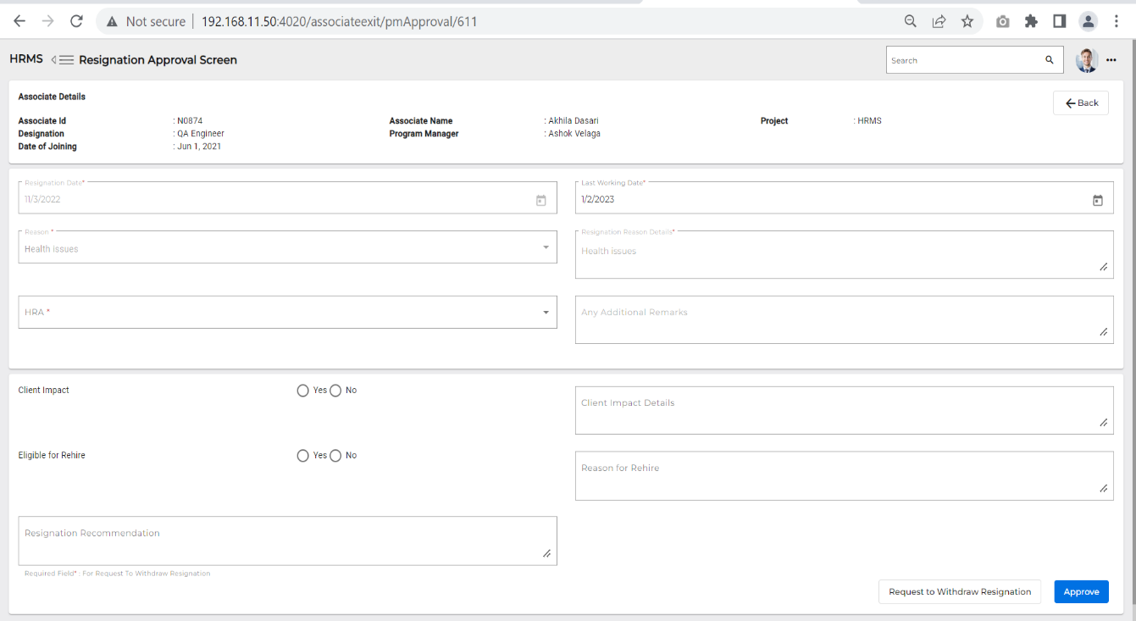

* **Email triggers to Team Lead, HRM, Associate’s** **Program Manager, Department heads, Manager-Finance, Manager- Talent Acquisition. Then the status changes to “Resignation Accepted by HRM”**

1. The Team lead can start the KT plan.
2. HRA can Initiate activities.
3. Corporate can start Exit interviews parallelly.
4. **Revoke Approval/Reject by HRM**
5. Associate submits the resignation and can revoke the resignation. Accept/Reject can be done by HRM.
6. HRM needs to login into the portal (Via single sign-on) with SenecaGlobal email Id. After authentication, HRM will be redirected to the Dashboard page. HRM needs to click on the **Associate Exit** section and an **Exit-Action** module.
7. HRM can view the associate who submitted **Revoke**, and the Status is changed to ‘**Revoke Initiated**.’
8. HRM needs to click on Actions button – ‘**Accept**’ (right mark).

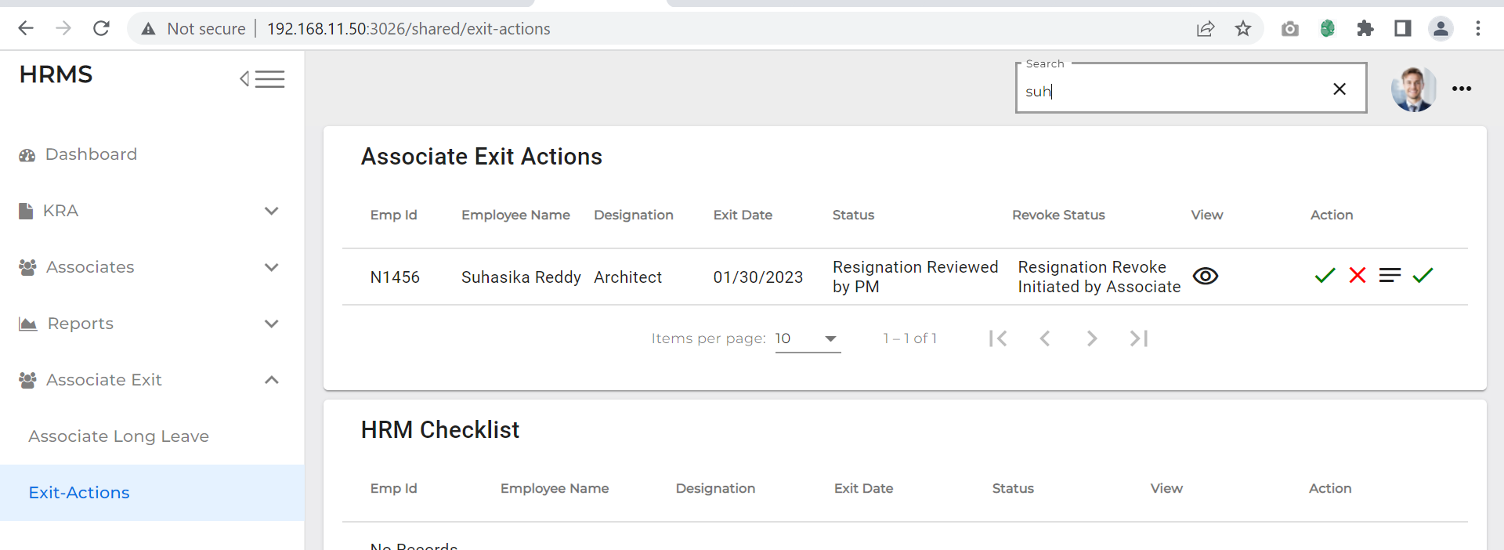

**When HRM Accepts, an Email is triggered to the Associate, Team lead, HRM and Program Manager then data will be removed from the HRM Exit actions**

1. HRM can Reject Resignation (cross mark) by giving the suitable reason and click on submit button then Revoke status is changes to “**Resignation Revoke Rejected by HRM**” and Exit flow will continue

1. **HRM (closer)**
2. Once all the departments’ checklists are submitted, Corporate gives Exit feedback and KT plan is done.
3. HRM can view associate data to give final clearance
4. HRM needs to login to the portal (Via single sign-on) with SenecaGlobal email Id. After authentication, HRM will be redirected to the Dashboard page. They need to click on **Associate Exit section** **and Exit-Action** module.
5. Once the departments checklist changed to green colour (Checklist completed)
6. Once all the department checklists and exit interview is done then HR can provide the remarks and then click on “Deactivate” button.

* **If HRA Activities or KT plan or Exit interview any one of these actions is not completed, then associate data is not available on HRM Exit-Actions screen**
* **Once all the activities, KT plan and Exit interview is done HRM can give final Exit clearance**

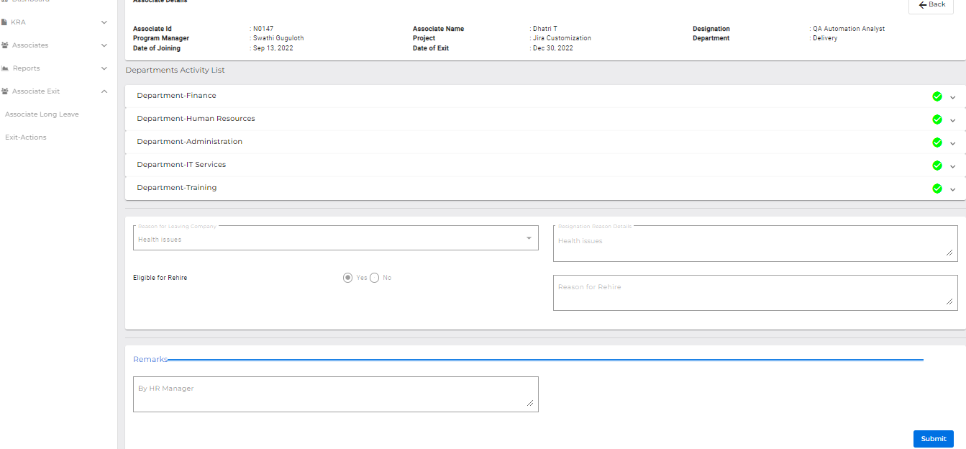

1. Associate data should be removed from the HRM Exit-Actions dashboard

* **Account will be deactivated from HRM application**
* **Status is changed to ‘Associate Resignation is Completed’ and an email notification is triggered to the HRM and other department heads.**
* **Till last working date associate data is available for service departments, HRA and Corporate. On Associate and HRM dashboard we can check or track the status of associate till Final approval is given by HRM**